<To the Editorial Board of Korean Management Review>

1. Title of the Manuscript: The impact of digital literacy on OO performance: A case study in OO

2. Submission Area: Management Information Systems

3. Manuscript Length: Total of 00 pages

4. Submission Date: 2025.00.00

How Digital Literacy Impacts OO Performance: A Focus on OO

Abstract

This study explores the relationship between digital technology orientation (DTO) and firms' OO performance. DTO is divided into five dimensions: artificial intelligence, blockchain, cloud computing, big data, and digital technology applications. We propose three key hypotheses and analyze data from 00,000 observations collected between 20XX and 20XX, obtained from a reputable corporate database. Using fixed and random effects panel models, we find that DTO has an overall positive effect on OO performance, with the effects of artificial intelligence, cloud computing, and digital technology applications being particularly significant. Moderation analysis further reveals that large firms tend to gain greater OO performance benefits from DTO compared to small firms.

Keyword: Digital Literacy, OO Performance, AI, Cloud Computing

I. Introduction
Digital literacy refers to a firm’s strategic orientation toward actively utilizing digital technologies to enhance operational efficiency and secure competitiveness across diverse markets. It encompasses not only the adoption of technology but also broader organizational transformations, including business process innovation, organizational flexibility, and data-driven decision-making capabilities. The significance of digital technologies in improving firm-level OO performance has increasingly gained attention in recent years (Yang, 2024; Hervé et al., 2021a). This trend highlights how digital technologies contribute not only to the efficient allocation of corporate resources and operational optimization but also to the creation of new market opportunities beyond the constraints of time and space (Yang et al., 2024).
This study aims to achieve two primary objectives. First, it conceptualizes digital literacy across five dimensions: data analytics, artificial intelligence (AI) utilization, cloud computing operations, cybersecurity awareness, and digital collaboration capabilities. Second, it systematically examines how these five dimensions influence a firm’s OO performance. To this end, the study proposes three key hypotheses: (1) digital literacy enhances firm-level OO performance; (2) data analytics, AI utilization, and digital collaboration capabilities have a more substantial impact on performance compared to the other dimensions; and (3) the performance-enhancing effect of digital literacy is more pronounced in large enterprises. These hypotheses will be empirically tested using a dataset of 00,000 firms collected between 20XX and 20XX.

II. Digital Literacy Dimensions and OO Performance
- Definition of Digital Literacy
Digital literacy refers to the process by which firms actively adopt digital technologies to transform their business processes, organizational structures, and corporate cultures. It extends beyond mere technology adoption to encompass a reconfiguration of value creation across the organization, emphasizing data-driven decision-making, agile market responsiveness, and service quality enhancement (Ahn & Lee, 2024). Key components include data analytics, artificial intelligence (AI), cloud technologies, cybersecurity, and digital collaboration. Through these capabilities, firms can simultaneously improve operational efficiency, enhance customer experience, and strengthen global competitiveness.

- Components of Digital Literacy
Digital literacy is not a singular technological capability, but rather an integrative concept where multiple components function synergistically (Yang et al., 2017). Based on previous research and industry case analyses, this study conceptualizes digital literacy through the following five dimensions:

- Data Analytics Capability
Data analytics refers to a firm’s ability to collect, process, and interpret large-scale data to support strategic decision-making (Adamson et al., 2017). This capability is particularly valuable in complex market environments, where it can be used to analyze consumer behavior, forecast demand, and assess competitive dynamics, thereby enabling the development of more refined international market entry strategies. Data-driven insights reduce risk and optimize resource allocation, increasing the likelihood of successful global operations.

- Determinants of OO Performance
In global markets, a firm’s OO performance is influenced by a range of factors, among which digital literacy is increasingly recognized as a critical enabler. First, digital capabilities enhance a firm's agility in responding to market complexity and uncertainty. Second, digital-driven process innovation reduces operational costs and accelerates entry into new markets. Third, digital collaboration tools and communication platforms provide the infrastructure necessary for effective engagement with consumers and partners across diverse cultural contexts (Waller & Fawcett, 2013). As such, systematically strengthening digital literacy plays a vital role in enabling firms to achieve and sustain competitive advantage in the global marketplace.

III. Research Hypotheses
Digital literacy plays a crucial role in enhancing firms’ OO performance by integrating advanced technologies and innovative management strategies. First, digitalization enables firms to respond rapidly to global market shifts by generating data-driven insights. With strong data analytics capabilities, firms can monitor consumer behavior, market trends, and competitive risks in real time, thereby supporting strategic decision-making. For instance, analyzing data from online platforms allows firms to detect demand shifts across markets at an early stage and promptly adjust their product and service strategies (Wu et al., 2024). Based on this rationale, the study proposes the following three hypotheses:
Hypothesis 1 (H1): Digital literacy improves a firm’s OO performance.
Figure 1 illustrates the research framework summarizing the three hypotheses introduced above.
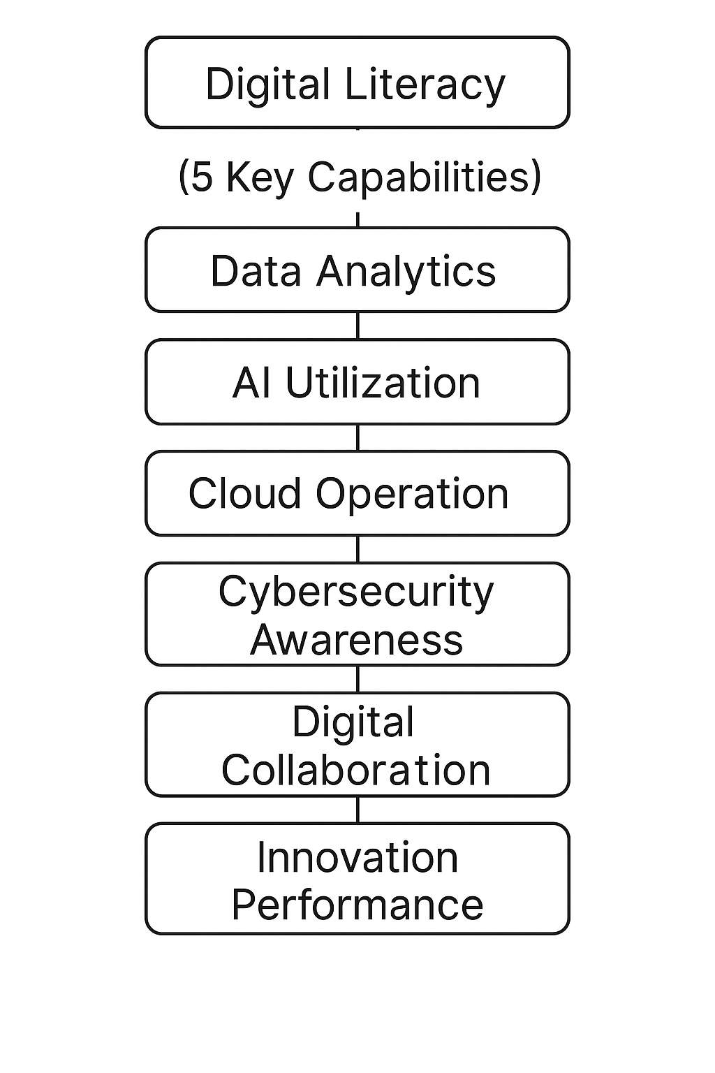
<Figure 1> Research Framework.

IV. Data and Variables
- Data Sources and Sample Selection
This study targets all publicly listed firms, excluding those in special situations (e.g., firms under financial distress, delisted firms, and special financial institutions). Firms with a negative debt ratio or less than one year of listing were also excluded to minimize bias from abnormal financial structures or insufficient managerial data. In addition, firms in the financial sector (e.g., banks, insurance companies, securities firms) were removed from the sample due to the unique industrial structure and regulatory environment of the financial industry, which differs significantly from those of general manufacturing and service sectors. These exclusions ensure a more accurate and generalizable assessment of the relationship between digital literacy and OO performance.

- Variable Definition
To measure a firm’s OO performance, this study uses the number of overseas business locations as the dependent variable. To account for data normality, the natural logarithm of the variable was used. This indicator intuitively reflects the extent of a firm’s global expansion and is appropriate for measuring OO performance (Wu et al., 2024).

V. Empirical Results and Analysis
Table 1 summarizes the descriptive statistics of the main variables. Table 2 presents the correlation matrix among the variables. The correlation coefficient between the digital literacy index and OO performance was found to be 0.1XXX, which is statistically significant at the 1% level. The correlation coefficients among the variables were generally low, indicating that multicollinearity is not a concern in this study.

<Table 1> Data description.
Variables | Obs | Mean | Std. Dev. | Min | Max
In-house Model Operation | 30,000 | 0.5476 | 0.8182 | 0.0000 | 3.2958
Digital Technology Orientation | 30,000 | 1.6086 | 1.4289 | 0.0000 | 5.1705
Artificial Intelligence Technology | 30,000 | 0.4429 | 0.8156 | 0.0000 | 3.5553
Blockchain Technology | 30,000 | 0.0187 | 0.1123 | 0.0000 | 0.6931

Table 2 presents the results of the analysis testing Hypothesis 1. According to the findings, data analytics capability, AI utilization, and digital collaboration capability have a statistically significant and positive effect on firms’ OO performance. In contrast, cloud operation and cybersecurity awareness show relatively limited influence and do not reach statistical significance. These results suggest that among the dimensions of digital literacy, capabilities related to analysis, prediction, and collaboration play a more critical role in enhancing firm competitiveness in global markets. Furthermore, the Hausman test yielded a p-value of 0.0000, indicating that the fixed effects model is the appropriate specification for analyzing the data in this study.

<Table 2> Estimation Results for Hypothesis 1.
Variables | Fixed Effects Model –  Firm Performance | Random Effects Model –  Firm Performance
Data Analytics Capability | 0.0449***  (3.2567) | 0.0639***  (5.2133)
AI Utilization Capability | 0.0013  (0.0323) | -0.0078  (-0.3124)
Cloud Computing Technology | 0.0142*  (1.8642) | 0.0139**  (2.1342)
Big Data Technology | 0.0034  (0.6449) | 0.0062  (0.9275)
Hausman Test（P Value） | 250.42(0.0000)

VI. Conclusion and Implications
This study empirically examined the impact of digital literacy on firms’ OO performance. The analysis revealed that digital literacy plays a generally positive role in enhancing OO performance. In particular, specific capabilities such as data analytics, artificial intelligence (AI) utilization, and digital collaboration were found to significantly contribute to firms’ global expansion strategies (Park & Ko, 2024).
These findings offer several key implications. First, firms should move beyond the mere adoption of digital technologies and focus on their strategic application and capability development. Second, companies targeting global markets should prioritize strengthening data-driven decision-making, AI-based market forecasting, and digital collaboration infrastructure. Finally, as the effectiveness of digital literacy investments may vary depending on firm size, it is essential to formulate differentiated digital strategies tailored to the needs of large enterprises and small-to-medium-sized enterprises (SMEs), respectively.

References

Park, Y. S. and Ko, D. Y. (2024). “A Study on the Efficiency of High-Growth ICT Service Companies,” Korea Management Review, 53(2), pp.249-263.
Seo, M. K. (2018). An Empirical Study on the Effects of Job Training on Industry Productivity and Wage [Master’s Thesis(Doctoral dissertation), Yonsei University]
Ahn, S. H. and Lee, M. H. (2016). “Fourth Industrial Revolution Impact : How it Changes Jobs,” Korean Academic Society of Business Administration (KASBA) Joint Conference, Busan.
Yang, J. S., Ham, Y. G. and Kim, D. H. (2017). Introduction to Information Systems 6th ed., Hankyungsa Publishing, Seoul.
Yang, B. S., “Korea’s Dining Market Exceeds 100 Trillion Won Last Year, Up 9% Ye ar- over-Year,” Chosun Biz, https://biz.chosun. com/distribution/food/2024/04/04/VT UGF UOI6JAJXHLA6XQE57OL2I/, retrieved October 2024.
Adamson, G., Wang, L., Holm, M., and Moore, P., (2017), "Cloud manufacturing–a critical review of recent development and future trends," International Journal of Computer Integrated Manufacturing, 30(4-5), pp.347-380.
Hervé, A., Schmitt, C., and Baldegger, R., (2021a), "Digitalization, entrepreneurial orientation & internationalization of micro-, small-, and medium-sized enterprises," Technology Innovation Management Review, 10(4), pp.5-17.
Hervé, A., Schmitt, C., and Baldegger, R., (2021b), "Internationalization and digitalization: Applying digital technologies to the internationalization process of small and medium-sized enterprises," Technology Innovation Management Review, 10(7), pp.28-40.
Waller, M. A., and Fawcett, S. E. (2013), "Data science, predictive analytics, and big data: A revolution that will transform supply chain design and management," Journal of Business Logistics, 34(2), pp.77-84.
Wu, J., Qu, X., Sheng, L., and Chu, W., (2024), "Uncovering the dynamics of enterprises digital transformation research: A comparative review on literature before and after the Covid-19 pandemic," Heliyon, 10(5), pp.e26986.

